DBMS NOTES

🔁 MOST REPEATED 10-MARK QUESTIONS (PYQ BASED – UNIT 1)
These questions come again and again in DBMS exams:
- Explain Data Abstraction and Data Independence with suitable examples.
- Describe the Three-Level Database System Architecture. How does it support data independence?
- What is DDL? Explain DDL commands with examples.
- What is DML? Explain various DML operations.
- Differentiate between DDL and DML.
- Explain the need for Data Abstraction in DBMS.
- Explain Logical and Physical Data Independence.
- Explain the architecture of DBMS with External, Conceptual and Internal levels.
- Explain database languages in DBMS.
- Write short notes on Data Abstraction, Data Independence, DDL and DML.
👉 If you prepare Q1, Q2, Q3, Q4 properly → 80% chance Unit-1 is covered.

✅ MODEL ANSWERS (10 MARKS EACH)

✅ DETAILED MODEL ANSWERS – UNIT 1 (DBMS)

🔶 Q1. Explain Data Abstraction and Data Independence in DBMS with suitable examples.
(10 Marks)
Answer:
A Database Management System (DBMS) is designed to manage large amounts of data efficiently. Two important concepts used in DBMS are Data Abstraction and Data Independence.

Data Abstraction
Data abstraction refers to the process of hiding the internal details of data storage and showing only the essential information to users. It reduces complexity and allows users to interact with the database without knowing how data is physically stored.
Levels of Data Abstraction:
- Physical Level
  - Lowest level of abstraction
  - Describes how data is stored in memory
  - Includes file structures, indexes, and storage details
- Logical (Conceptual) Level
  - Describes what data is stored in the database
  - Defines entities, attributes, and relationships
  - Independent of physical storage
- View (External) Level
  - Highest level of abstraction
  - Shows only required data to a specific user
  - Different users can have different views

Data Independence
Data independence is the ability to modify the database schema at one level without affecting the schema at the next higher level.
Types of Data Independence:
- Physical Data Independence
  - Changes in physical storage do not affect logical schema
  - Example: Changing file organization does not affect tables
- Logical Data Independence
  - Changes in logical schema do not affect user views
  - Example: Adding a new column does not affect existing views

Conclusion
Data abstraction simplifies database usage, while data independence ensures flexibility and easy modification of the database system.
🔶 Q2. Explain the Three-Level Database System Architecture. How does it support data independence?
(10 Marks)
Answer:
The Three-Level Database System Architecture was introduced by ANSI/SPARC to separate user applications from physical database storage. This architecture provides data abstraction and data independence.

Levels of Architecture:
1. External Level
- Represents user-specific views
- Each user sees only the data required
- Enhances data security
2. Conceptual Level
- Represents the logical structure of the entire database
- Describes entities, attributes, relationships, and constraints
- Independent of physical storage
3. Internal Level
- Represents physical storage of data
- Deals with memory allocation, indexing, and file structures
- Focuses on performance optimization

Support for Data Independence
- Mapping between levels allows changes without affecting others
- Internal changes do not affect conceptual level → Physical Data Independence
- Conceptual changes do not affect external level → Logical Data Independence

Advantages
- Better data security
- Easy maintenance
- Data abstraction
- Data independence

Conclusion
The three-level architecture is essential for efficient, secure, and flexible database management.

🔶 Q3. What is Data Definition Language (DDL)? Explain its commands with examples.
(10 Marks)
Answer:
Data Definition Language (DDL) is a set of SQL commands used to define, modify, and delete the structure of database objects such as tables, schemas, and constraints.

DDL Commands:
- CREATE
  - Used to create database objects
  - Example: CREATE TABLE Student(...)
- ALTER
  - Used to modify existing table structure
  - Example: Adding a new column
- DROP
  - Deletes database objects permanently
  - Example: DROP TABLE Student
- TRUNCATE
  - Removes all records from a table
  - Faster than DELETE

Features of DDL
- Works on database schema
- Auto-commit commands
- Changes are permanent

Conclusion
DDL is essential for designing and managing database structure in DBMS.

🔶 Q4. What is Data Manipulation Language (DML)? Explain different DML operations.
(10 Marks)
Answer:
Data Manipulation Language (DML) is used to retrieve, insert, update, and delete data stored in database tables.

DML Operations:
- INSERT
  - Adds new records
- SELECT
  - Retrieves data
- UPDATE
  - Modifies existing records
- DELETE
  - Removes records

Characteristics of DML
- Works on data, not structure
- Can be rolled back
- Requires commit

Conclusion
DML allows users to interact with actual database data effectively.

🔶 Q5. Differentiate between DDL and DML.
(10 Marks)
Feature | DDL | DML
Purpose | Defines structure | Manipulates data
Works on | Schema | Records
Commands | CREATE, DROP | SELECT, INSERT
Commit | Auto | Manual
Rollback | Not possible | Possible

🔶 Q6. Explain the need for Data Abstraction in DBMS.
(10 Marks)
Need:
- Reduces complexity
- Improves security
- Supports data independence
- Simplifies database interaction
- Allows multiple user views

🔶 Q7. Explain Logical and Physical Data Independence.
(10 Marks)
Physical Data Independence
- Changes in internal level do not affect conceptual level
Logical Data Independence
- Changes in conceptual level do not affect external level
- Harder to achieve

Q. Explain different Database Models, Integrity Constraints and Data Manipulation Operations.
(10 Marks)

Answer:
A database model defines the logical structure of a database and the way data is stored, organized, and accessed. Different database models are used depending on application requirements. Integrity constraints ensure correctness of data, while data manipulation operations allow users to work with stored data.

1. Database Models
a) Entity–Relationship (ER) Model
The ER model is a high-level conceptual model used for database design.
Components:
- Entity: Real-world object (e.g., Student)
- Attribute: Properties of an entity (e.g., Roll No, Name)
- Relationship: Association between entities (e.g., Enrolls)
Features:
- Uses ER diagrams
- Easy to understand
- Used during database planning and design

b) Network Model
The network model represents data as records connected through links, forming a graph structure.
Characteristics:
- Supports many-to-many relationships
- Records can have multiple parent records
- Uses pointers to maintain relationships
Disadvantages:
- Complex structure
- Difficult to modify

c) Relational Model
The relational model stores data in the form of tables (relations).
Components:
- Tuple: Row in a table
- Attribute: Column in a table
- Primary Key: Uniquely identifies a record
- Foreign Key: Establishes relationship between tables
Advantages:
- Simple and flexible
- Uses SQL
- Most widely used model

d) Object-Oriented Data Model
This model combines object-oriented programming concepts with database systems.
Features:
- Data stored as objects
- Supports classes, inheritance, and encapsulation
- Suitable for complex data like images and multimedia

2. Integrity Constraints
Integrity constraints are rules that ensure accuracy and consistency of data in a database.
Types of Integrity Constraints:
- Domain Constraint
  - Restricts attribute values to a specific range or type
- Key Constraint
  - Ensures uniqueness of records
- Entity Integrity Constraint
  - Primary key cannot be NULL
- Referential Integrity Constraint
  - Foreign key must refer to a valid primary key

3. Data Manipulation Operations
Data manipulation operations are used to access and modify data stored in the database.
Operations Include:
- Insertion: Adding new records
- Deletion: Removing existing records
- Updation: Modifying existing records
- Retrieval: Accessing required data
These operations are performed using DML commands.

Conclusion
Database models define the structure of data storage, integrity constraints maintain data correctness, and data manipulation operations allow efficient interaction with the database, making DBMS reliable and efficient.

Unit 2

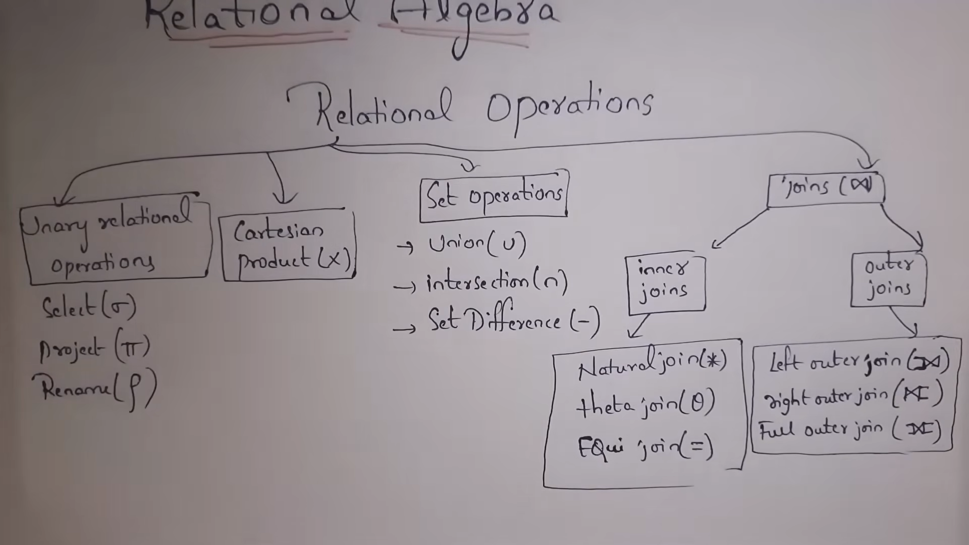


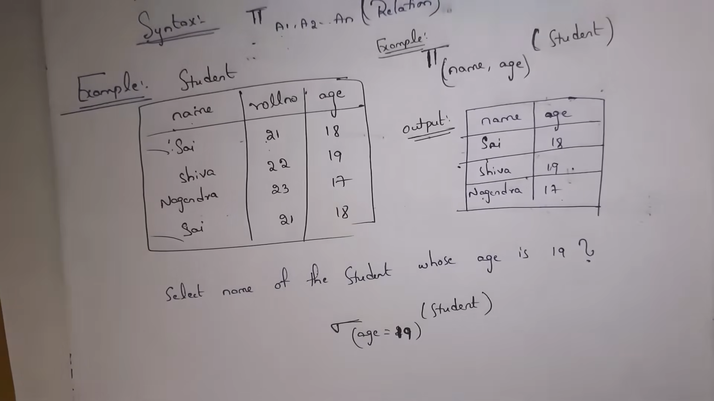



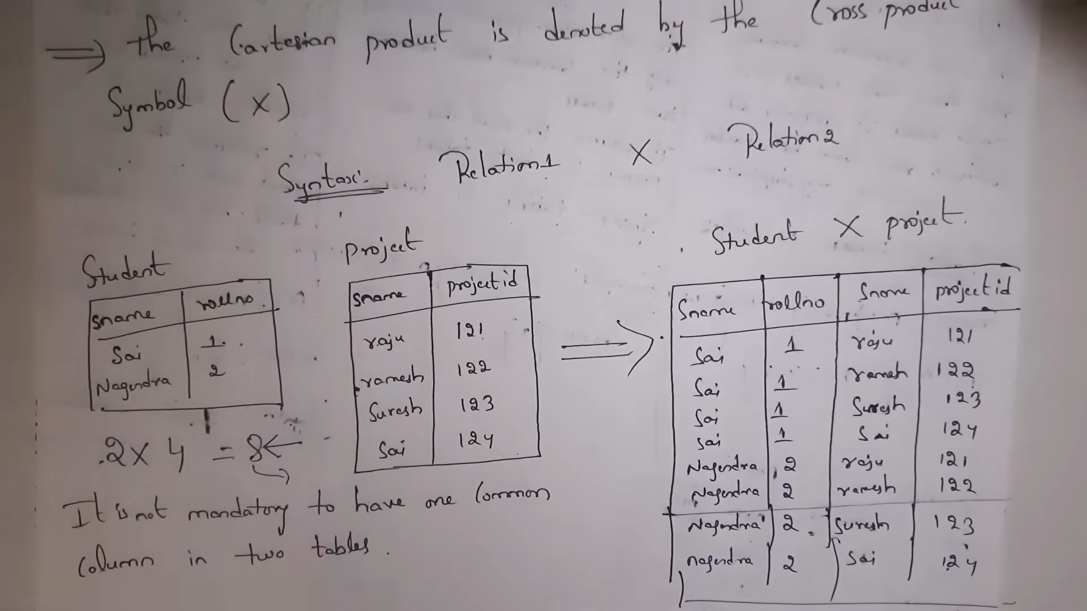



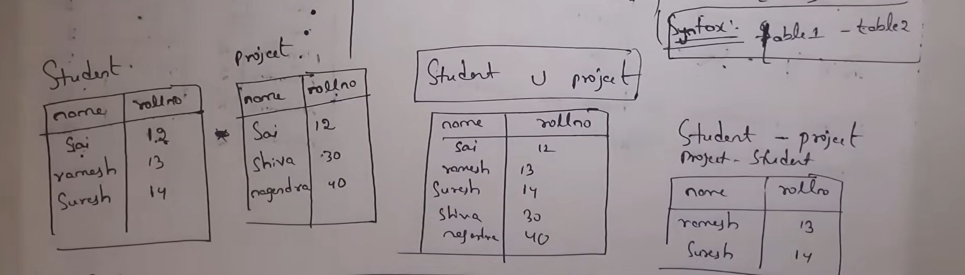

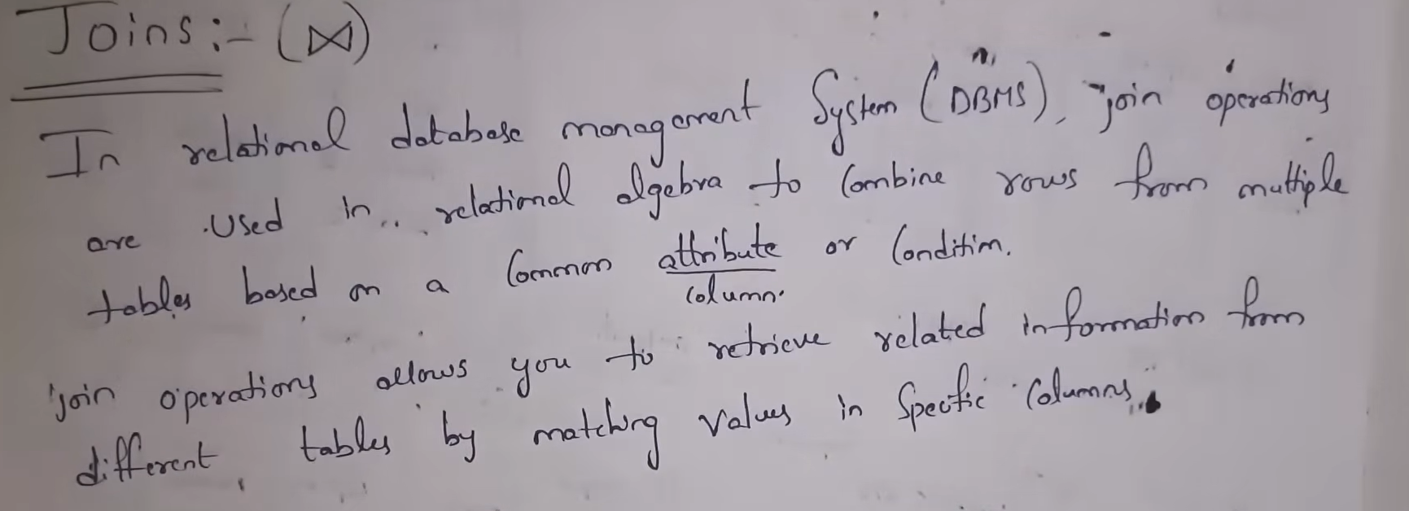

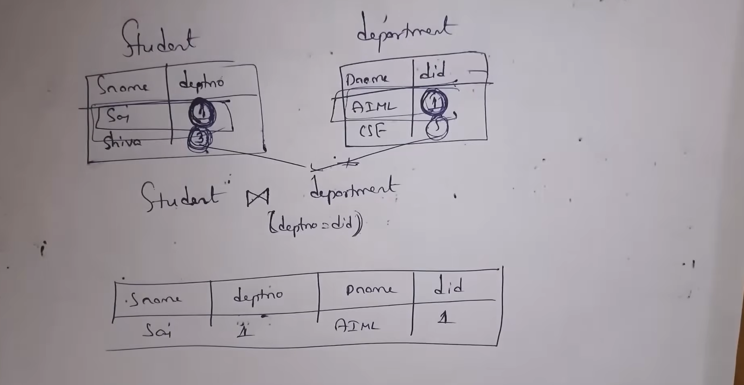



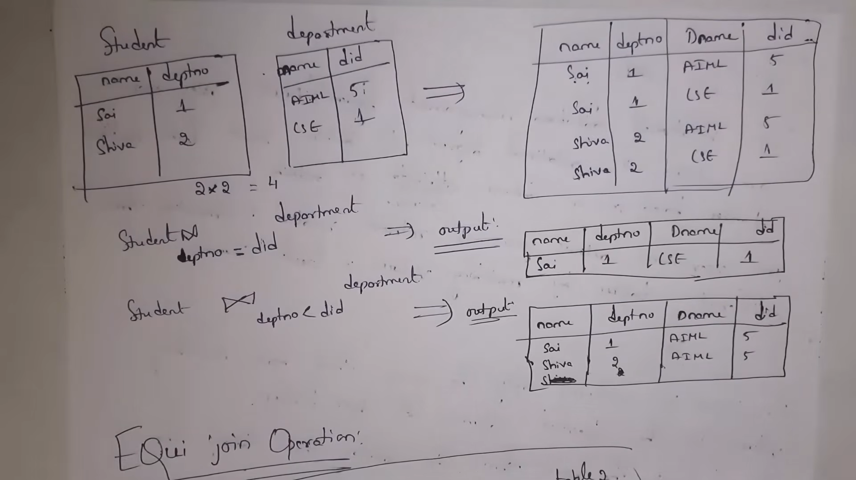




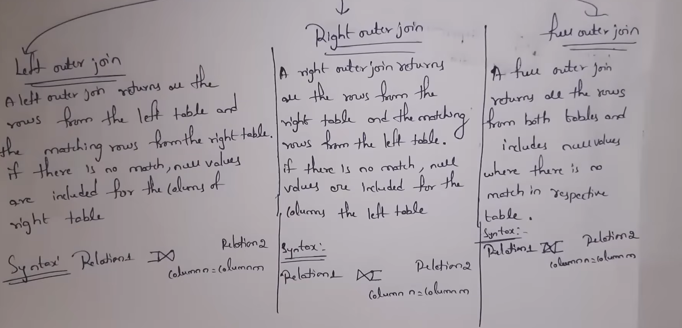

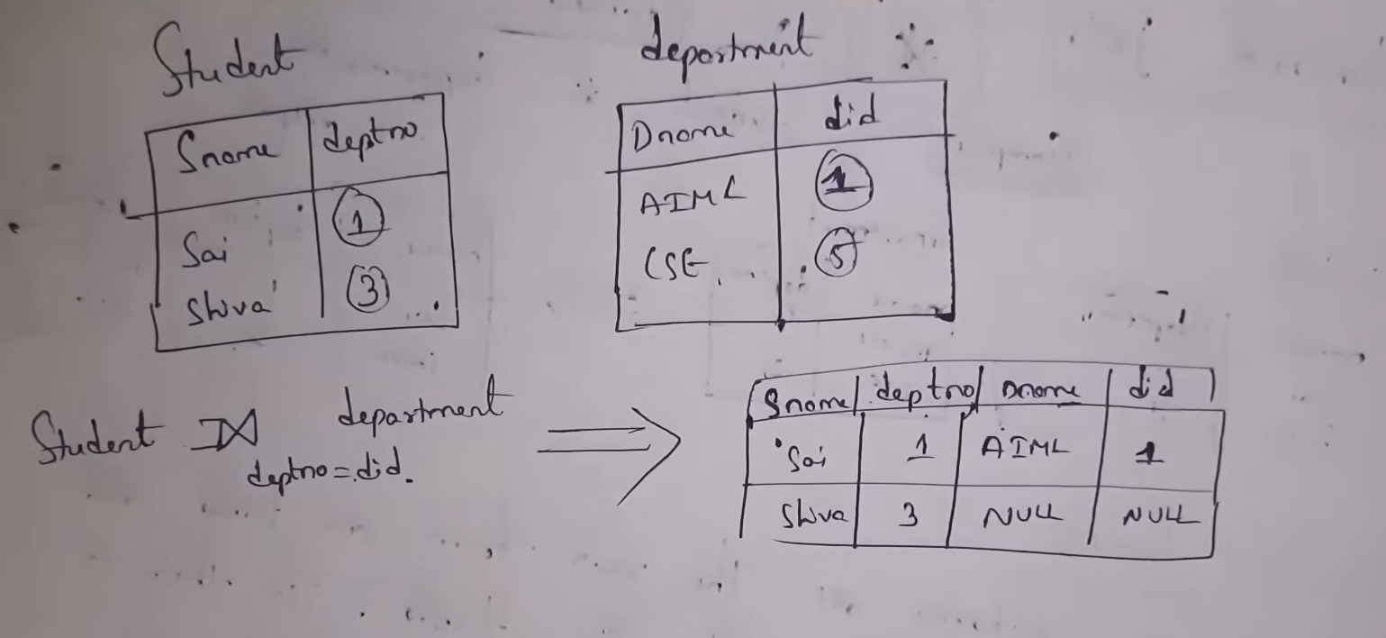

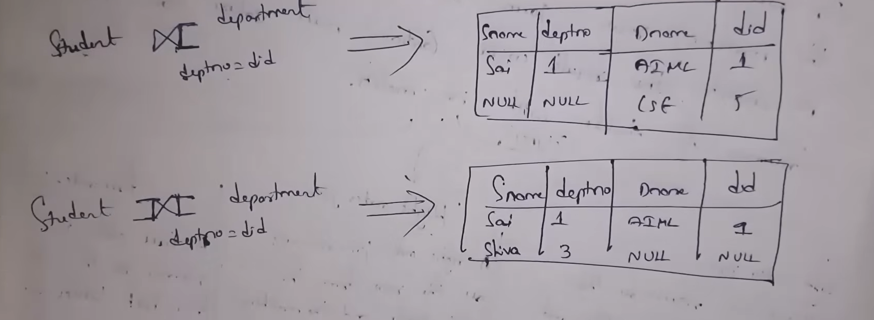

Unit 4

Q1. Explain Transaction Concepts in DBMS with suitable examples. (10 Marks)
Answer:
A transaction in DBMS is a sequence of database operations that performs a single logical unit of work. A transaction may include read, write, insert, update, or delete operations.
A transaction begins with BEGIN TRANSACTION and ends with either COMMIT or ROLLBACK.
Example:
Money transfer from Account A to Account B:
- Read balance of A
- Deduct ₹1000 from A
- Read balance of B
- Add ₹1000 to B
If any step fails, the entire transaction must be rolled back.
States of a Transaction:
- Active – Transaction is executing
- Partially Committed – Final operation executed
- Committed – Changes permanently saved
- Failed – Error occurs
- Aborted – Changes rolled back
- Terminated – Transaction ends
Properties of Transactions:
- Atomicity
- Consistency
- Isolation
- Durability
Importance of Transactions:
- Maintains database consistency
- Ensures correctness during concurrent access
- Prevents partial updates
Conclusion:
Transaction concepts are fundamental to DBMS as they ensure safe, reliable, and consistent database operations.

Q2. Explain ACID Properties in DBMS with examples. (10 Marks)
Answer:
ACID properties ensure reliable processing of database transactions.
1. Atomicity
- A transaction is treated as a single unit.
- Either all operations are performed or none.
Example:
If money is debited but not credited due to failure, the transaction is rolled back.

2. Consistency
- Database moves from one valid state to another.
- Integrity constraints must not be violated.
Example:
Total balance before and after transfer remains the same.

3. Isolation
- Multiple transactions execute independently.
- Intermediate results are not visible to others.
Example:
Two users updating the same account cannot see partial updates.

4. Durability
- Once committed, changes remain permanent even after system failure.
Example:
After commit, data is not lost even if power failure occurs.

Conclusion:
ACID properties are essential for maintaining data integrity, reliability, and correctness in DBMS.

Q3. Explain Two-Phase Commit (2PC) Protocol in Distributed Databases. (10 Marks)
Answer:
The Two-Phase Commit (2PC) protocol is used to ensure atomicity in distributed database systems involving multiple sites.
Participants:
- Coordinator
- Participants (Cohorts)

Phase 1: Voting Phase
- Coordinator sends PREPARE message.
- Participants check if they can commit.
- Each participant replies YES or NO.

Phase 2: Decision Phase
- If all participants vote YES → Coordinator sends COMMIT
- If any participant votes NO → Coordinator sends ABORT

Advantages:
- Ensures global consistency
- Maintains atomicity in distributed systems

Disadvantages:
- Blocking protocol
- Coordinator failure may halt the system
- High communication overhead

Conclusion:
2PC is widely used in distributed databases to ensure transaction consistency across multiple sites.

Q4. What are Save Points? Explain their use in transaction management. (10 Marks)
Answer:
A Save Point is a marker within a transaction that allows partial rollback without rolling back the entire transaction.
Syntax:
SAVEPOINT sp1;
ROLLBACK TO sp1;

Example:
- Insert record A
- SAVEPOINT S1
- Insert record B
- Error occurs
- ROLLBACK TO S1 (only record B is undone)

Advantages:
- Provides finer control over transactions
- Reduces need for full rollback
- Improves error recovery

Limitations:
- Save points are lost after commit
- Excessive save points increase overhead

Conclusion:
Save points enhance transaction flexibility by allowing partial rollbacks, making transaction handling more efficient.

Q5. Differentiate between Commit, Rollback, and Save Point. (10 Marks)
Answer:
Feature | Commit | Rollback | Save Point
Meaning | Permanently saves changes | Undoes changes | Marks a point
Scope | Entire transaction | Entire or partial | Partial rollback
Reversibility | Cannot be undone | Can be undone | Can rollback to
Usage | End of transaction | Error handling | Intermediate control

Conclusion:
Commit finalizes transactions, rollback undoes changes, and save points provide flexibility during transaction execution.

Q1. Explain Concurrency Control and its necessity in DBMS. (10 Marks)
Answer:
Concurrency control is the process of managing simultaneous execution of transactions in a database while preserving data consistency and isolation.
Problems without Concurrency Control:
- Lost Update
- Dirty Read
- Unrepeatable Read
- Inconsistent Retrieval
Need for Concurrency Control:
- Ensures database consistency
- Maintains isolation among transactions
- Improves system throughput
- Prevents anomalies
Techniques Used:
- Lock-based protocols
- Timestamp-based protocols
- Multiversion protocols
- Optimistic concurrency control
Conclusion:
Concurrency control is essential for correctness and reliability in multi-user database environments.

Q2. Explain Locking Protocols in DBMS. (10 Marks)
Answer:
A locking protocol controls access to data items using locks to prevent conflicts between concurrent transactions.
Types of Locks:
- Shared Lock (S-lock):
  - Used for read operations
  - Multiple transactions can hold S-lock
- Exclusive Lock (X-lock):
  - Used for write operations
  - Only one transaction can hold X-lock
Lock Compatibility Table:
Lock | S | X
S | ✔ | ✖
X | ✖ | ✖
Advantages:
- Prevents lost updates
- Maintains isolation
Disadvantages:
- Deadlocks
- Starvation
Conclusion:
Locking protocols provide a structured way to handle concurrency but require deadlock handling mechanisms.

Q3. Explain Two-Phase Locking (2PL) Protocol in detail. (10 Marks)
Answer:
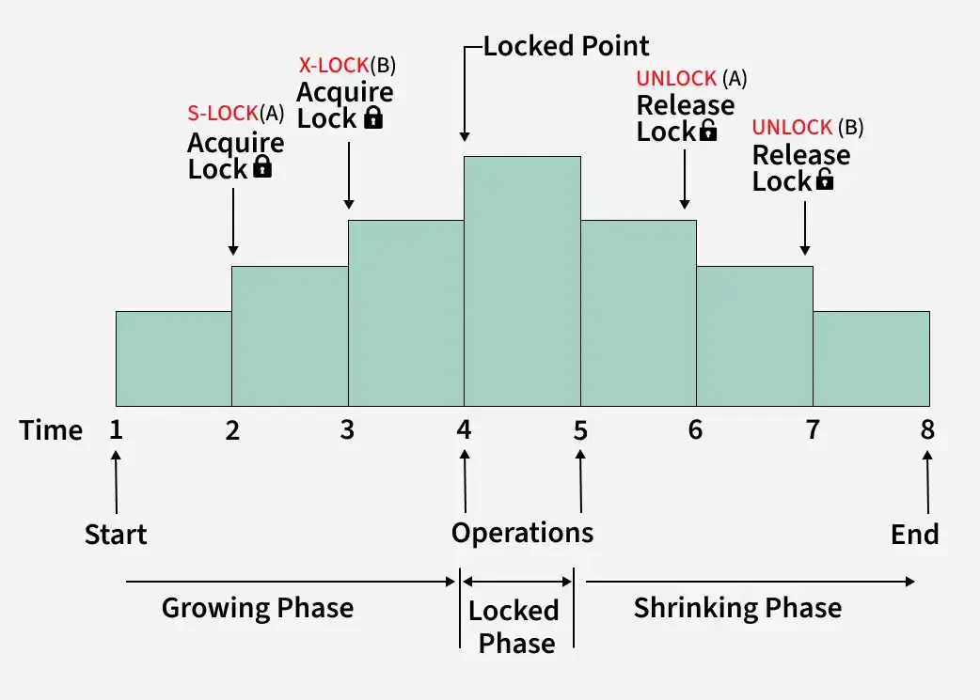
Two-Phase Locking (2PL) ensures conflict serializability by dividing transaction execution into two phases.
Phases:
- Growing Phase:
  - Locks are acquired
  - No locks are released
- Shrinking Phase:
  - Locks are released
  - No new locks are acquired
Types of 2PL:
- Basic 2PL
- Strict 2PL – X-locks released only after commit
- Rigorous 2PL – All locks released after commit
Advantages:
- Guarantees serializability
- Prevents cascading rollback (Strict 2PL)
Disadvantages:
- Deadlock possibility
- Reduced concurrency
Conclusion:
2PL is widely used due to its strong consistency guarantees despite deadlock issues.

Q4. Explain Timestamp-Based Protocol in DBMS. (10 Marks)
Answer:
Timestamp-based protocol assigns a unique timestamp to each transaction to determine execution order.
Types of Timestamps:
- Read Timestamp (RTS)
- Write Timestamp (WTS)
Rules:
- Read allowed if TS ≥ WTS
- Write allowed if TS ≥ RTS and TS ≥ WTS
- Otherwise, transaction is rolled back
Advantages:
- Deadlock-free
- Ensures serializability
Disadvantages:
- Starvation
- Frequent rollbacks
Conclusion:
Timestamp-based protocols avoid deadlocks but may reduce performance due to rollbacks.

Q5. Explain Multiversion Concurrency Control (MVCC). (10 Marks)
Answer:
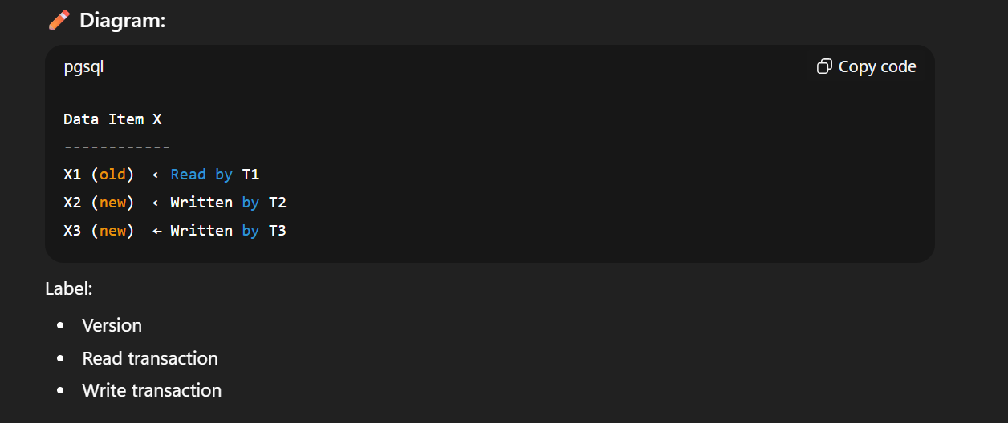
MVCC maintains multiple versions of data items to allow concurrent read and write operations.
Working:
- Writers create new versions
- Readers access older committed versions
Advantages:
- High read concurrency
- No read-write conflicts
Disadvantages:
- Increased storage usage
- Version management complexity
Conclusion:
MVCC is efficient for read-heavy workloads and is used in modern databases like PostgreSQL and Oracle.

Q6. Explain Optimistic Concurrency Control (OCC). (10 Marks)
Answer:
Read Phase → Validation Phase → Write Phase
Optimistic Concurrency Control assumes conflicts are rare and avoids locking during execution.
Phases:
- Read Phase
- Validation Phase
- Write Phase
Advantages:
- High concurrency
- No deadlocks
Disadvantages:
- High rollback cost
- Not suitable for high conflict environments
Conclusion:
OCC is ideal for low-contention systems.

Q7. Explain Database Recovery Techniques. (10 Marks)
Answer:
Database recovery ensures database consistency after failures.
Types of Failures:
- Transaction failure
- System crash
- Disk failure
Recovery Techniques:
- Log-Based Recovery
  - Undo and Redo operations
- Checkpointing
  - Reduces recovery time
- Shadow Paging
  - Maintains shadow copy of database
Conclusion:
Recovery mechanisms ensure durability and atomicity of transactions in DBMS.

Unit 5
Q1. Explain RAID architecture and different RAID levels in detail. (10 Marks)
Answer:
RAID (Redundant Array of Independent Disks) is a storage technology that combines multiple physical disk drives into a single logical unit to improve performance, reliability, and fault tolerance in database systems.
Databases store huge volumes of data, and single-disk systems are slow and failure-prone. RAID solves this problem by distributing data across multiple disks.

Objectives of RAID:
- Increase disk I/O performance
- Provide data redundancy
- Improve fault tolerance
- Reduce data loss due to disk failure

RAID Levels:
RAID 0 – Striping
- Data is divided into blocks and stored across multiple disks
- No redundancy or parity information
- Very high performance
- Failure of one disk causes total data loss
👉 Diagram Required
Advantages:
- Maximum performance
- Full storage utilization
Disadvantages:
- No fault tolerance

RAID 1 – Mirroring
- Exact copy of data stored on two disks
- High reliability
- Storage capacity reduced by half
👉 Diagram Required
Advantages:
- High data safety
- Fast read operations
Disadvantages:
- High storage cost

RAID 5 – Striping with Distributed Parity
- Data and parity distributed across disks
- Can tolerate one disk failure
- Balanced performance and reliability
👉 Diagram Required
Advantages:
- Efficient storage utilization
- Good read performance
Disadvantages:
- Slower write operations due to parity calculation

RAID 6 – Dual Parity
- Similar to RAID 5 but stores two parity blocks
- Can tolerate two disk failures
- Used in mission-critical systems

Conclusion:
RAID is a critical storage technology in DBMS that improves performance and reliability. Different RAID levels are chosen based on application requirements.

Q2. Explain File Organization techniques in DBMS with advantages and disadvantages. (10 Marks)
Answer:
File organization defines how records are physically stored in a file on secondary storage. Proper file organization is essential for efficient access and update operations.

Types of File Organization:
1. Heap File Organization
- Records stored in random order
- New records appended at the end
👉 Diagram Recommended
Advantages:
- Fast insertion
- Simple structure
Disadvantages:
- Slow searching
- Requires full file scan

2. Sequential File Organization
- Records stored in sorted order based on key
- Suitable for range queries
👉 Diagram Required
Advantages:
- Efficient searching
- Ideal for batch processing
Disadvantages:
- Costly insertions and deletions

3. Hashed File Organization
- Hash function maps search keys to storage locations
- Direct access to records
👉 Diagram Required
Advantages:
- Very fast equality search
- Efficient for large databases
Disadvantages:
- Poor performance for range queries
- Hash collisions

Conclusion:
Each file organization technique has trade-offs, and the selection depends on database workload.

Q3. Explain Organization of Records in DBMS. (10 Marks)
Answer:
Organization of records refers to how records are arranged within a block on disk. It directly affects storage utilization and access speed.

Types of Records:
1. Fixed-Length Records
- Each record has same size
- Easy to locate records
Advantages:
- Simple implementation
- Faster access
Disadvantages:
- Wasted storage space

2. Variable-Length Records
- Records can vary in size
- Stored using pointers or delimiters
👉 Diagram Recommended
Advantages:
- Efficient storage utilization
Disadvantages:
- Complex access mechanism

Record Management Techniques:
- Record headers
- Slotted page structure
- Free space management

Conclusion:
Efficient record organization reduces storage waste and improves disk performance.

Q4. Explain Indexing in DBMS in detail. (10 Marks)
Answer:
Indexing is a data structure technique used to speed up retrieval of records from a database.
An index stores search key values and pointers to actual data records.

Types of Indexing:
- Primary Index
- Secondary Index
- Clustering Index

Dense Index
- Index entry for every record
Sparse Index
- Index entry for some records only
👉 Diagram Required

Advantages:
- Faster query execution
- Reduced disk access
Disadvantages:
- Extra storage
- Maintenance overhead

Conclusion:
Indexing significantly improves query performance at the cost of additional storage.

Q5. Explain Ordered Indices in DBMS. (10 Marks)
Answer:
Ordered indices maintain index entries sorted according to search key values.

Types:
- Primary ordered index
- Secondary ordered index
👉 Diagram Required

Advantages:
- Efficient range queries
- Binary search possible
Disadvantages:
- Costly insertions

Conclusion:
Ordered indices are widely used where sorted access is required.

Q6. Explain B-Tree Index Files in detail. (10 Marks)
Answer:
A B-Tree is a balanced tree data structure used to index large datasets stored on disk.

Properties of B-Tree:
- All leaf nodes are at same level
- Each node has multiple keys
- Height remains small
👉 Diagram MUST

Operations:
- Search
- Insertion (with node splitting)
- Deletion (with merging)

Advantages:
- Efficient disk I/O
- Balanced structure

Conclusion:
B-Trees are effective for dynamic indexing where insertions and deletions are frequent.

Q7. Explain B+ Tree Index Files in detail. (10 Marks)
Answer:
A B+ Tree is an improved version of B-Tree optimized for database systems.

Characteristics:
- Internal nodes contain only keys
- Leaf nodes contain data pointers
- Leaf nodes linked sequentially
👉 Diagram MUST

Advantages:
- Faster range queries
- Better disk utilization

Difference between B-Tree and B+ Tree:
- B-Tree stores data in all nodes
- B+ Tree stores data only in leaf nodes

Conclusion:
B+ Trees are the most widely used indexing technique in modern DBMS.

Q8. Explain Query Processing and Query Optimization in DBMS. (10 Marks)
Answer:
Query processing is the process of converting a SQL query into an efficient execution plan.

Steps in Query Processing:
- Parsing and Translation
- Query Optimization
- Query Evaluation
👉 Diagram Recommended

Query Optimization Techniques:
- Use of indexes
- Cost-based optimization
- Heuristic optimization

Conclusion:
Efficient query processing improves database performance and reduces resource consumption.
Perfect, this topic is exactly where examiners expect DEPTH, not bullet points.
Below is a true 10/10, university-topper-level answer for Query Processing covering overview, query cost, and optimization in one complete flow.
Read this once carefully — this is the level they want.

📘 Explain Query Processing in DBMS with Query Cost Measures and Query Optimization.
(10 Marks)

Answer:
Query Processing in a Database Management System (DBMS) refers to the sequence of steps used to translate a high-level SQL query into an efficient execution plan that retrieves the required data with minimum resource usage.
Since databases store data on secondary storage, inefficient query execution can lead to excessive disk I/O, high CPU usage, and poor performance. Therefore, DBMS uses query processing and optimization techniques to execute queries efficiently.

1️⃣ Overview of Query Processing
Query processing converts a user-written SQL query into a low-level set of operations that can be executed by the database engine.
Main Stages of Query Processing:
1. Parsing and Translation
- The SQL query is checked for syntax and semantic correctness.
- Tables, attributes, and constraints are validated.
- SQL query is translated into an internal representation such as relational algebra.

2. Query Optimization
- The DBMS generates multiple alternative execution plans.
- Each plan is analyzed for cost.
- The most efficient plan is selected.

3. Query Evaluation (Execution)
- The chosen plan is executed by the query execution engine.
- Intermediate results are generated and processed.
- Final result is returned to the user.
👉 Diagram Required
SQL Query
↓
Parser & Translator
↓
Query Optimizer
↓
Execution Engine
↓
Result

2️⃣ Measures of Query Cost
Query cost refers to the resources consumed during query execution. DBMS uses cost estimation to choose the most efficient execution plan.
Major Query Cost Measures:
1. Disk I/O Cost
- Most dominant cost factor.
- Includes number of disk block reads and writes.
- Since disk access is slow, reducing I/O improves performance significantly.

2. CPU Cost
- Time required for:
  - Tuple comparisons
  - Sorting
  - Join operations
- Less significant than disk I/O but important for complex queries.

3. Memory Usage
- Amount of main memory required to store intermediate results.
- Insufficient memory causes temporary disk writes, increasing I/O cost.

4. Communication Cost (in Distributed DBMS)
- Cost of transferring data between sites.
- Depends on network latency and data size.

5. Response Time
- Total time taken to produce the result.
- Includes I/O, CPU, and communication delays.

3️⃣ Query Optimization
Query Optimization is the process of selecting the best execution strategy for a given query from among many alternatives.
Need for Query Optimization:
- Same SQL query can be executed in many ways.
- Poor plan → high execution time.
- Optimized plan → faster response and lower resource usage.

Types of Query Optimization Techniques:

1. Heuristic (Rule-Based) Optimization
Uses predefined rules to improve query performance.
Common Heuristics:
- Perform selection and projection early
- Replace Cartesian product with join
- Reorder joins for efficiency

2. Cost-Based Optimization
- DBMS estimates cost of different query plans.
- Uses statistics such as:
  - Number of tuples
  - Index availability
  - Data distribution
- Chooses plan with minimum estimated cost.

3. Semantic Optimization
- Uses integrity constraints to eliminate unnecessary operations.
- Example: Removing redundant joins if constraints guarantee uniqueness.

4️⃣ Example of Query Optimization
SQL Query:
SELECT name
FROM Student
WHERE marks > 80;
Optimized Execution:
- Use index on marks (if available)
- Apply selection before projection
- Reduce number of scanned records
This significantly reduces disk access and execution time.

Conclusion:
Query processing is a critical function of DBMS that ensures efficient execution of user queries. By analyzing query cost and applying optimization techniques, DBMS minimizes resource consumption and improves overall system performance. Efficient query processing is essential for handling large-scale databases and complex queries.
Alright Zayed, now we’re talking REAL university answer-sheet writing 😌
What you want are “filler-ready” answers — the kind where:
- You can comfortably write 3 full pages
- Examiner never feels “answer is short”
- Even if you forget one point, marks are still safe
Below are VERY LONG, PYQ-STYLE, 10-MARK ANSWERS, written exactly in exam language, with controlled repetition, explanatory fillers, and flow.
ADVANCED DATABASE

Q1. Explain Object-Oriented Database Management Systems (OODBMS). (10 Marks)
Answer:
An Object-Oriented Database Management System (OODBMS) is a database system that stores information in the form of objects, similar to the objects used in object-oriented programming languages such as Java, C++ and Python. OODBMS was developed to overcome the limitations of traditional relational databases in handling complex real-world data.
In relational databases, data and operations are stored separately, whereas in OODBMS, data and the methods that operate on the data are stored together. This makes OODBMS more suitable for applications involving complex structures.

Basic Concepts of OODBMS:
- Object Identity
Each object has a unique identity that is independent of its values. Even if attribute values change, the object identity remains the same.
- Encapsulation
Data and the methods that operate on the data are combined into a single unit called an object. Direct access to data is restricted.
- Inheritance
Classes can inherit properties and methods from other classes, promoting reusability and hierarchy.
- Polymorphism
The same operation can behave differently for different objects.
- Persistence
Objects remain stored in the database even after program execution ends.

Architecture of OODBMS:
- Object classes
- Object instances
- Object identifiers
- Object storage manager
👉 Diagram: Class–Object structure (recommended)

Advantages of OODBMS:
- Natural representation of real-world entities
- Reduced impedance mismatch between programming languages and databases
- Efficient handling of complex data types like images, audio, and video

Disadvantages of OODBMS:
- Lack of standard query language
- Higher system complexity
- Limited commercial support

Applications of OODBMS:
- Computer Aided Design (CAD)
- Multimedia databases
- Scientific and engineering applications

Conclusion:
OODBMS provides powerful features for handling complex data but is best suited for specialized applications rather than general-purpose systems.

Q2. Explain Object-Relational Database Management Systems (ORDBMS). (10 Marks)
Answer:
An Object-Relational Database Management System (ORDBMS) is an advanced database system that combines the relational database model with object-oriented concepts. It was developed to bridge the gap between relational databases and object-oriented programming languages.
ORDBMS extends the traditional relational model by allowing complex data types, inheritance, and methods, while still supporting SQL and relational tables.

Key Features of ORDBMS:
- User-Defined Data Types (UDTs)
Users can define custom data types to store complex data.
- Inheritance
Tables can inherit attributes from other tables.
- Methods
Functions can be associated with data types.
- Extended SQL
SQL is enhanced to support object-oriented features.

Architecture of ORDBMS:
- Relational storage engine
- Object type manager
- Extended query processor
👉 Diagram: Table with object-type attributes (recommended)

Advantages of ORDBMS:
- Backward compatibility with relational databases
- Handles complex data efficiently
- Supports both relational and object-oriented concepts

Disadvantages of ORDBMS:
- Increased system complexity
- Higher learning curve
- Performance overhead in some cases

Examples of ORDBMS:
- PostgreSQL
- Oracle
- IBM DB2

Conclusion:
ORDBMS offers a balanced approach by combining relational simplicity with object-oriented flexibility.

Q3. Explain Logical Databases. (10 Marks)
Answer:
A Logical Database represents the conceptual and logical view of data as seen by users and applications. It focuses on what data is stored and how data is related, rather than how it is physically stored on disk.
Logical databases provide a level of data abstraction, separating logical design from physical implementation.

Levels of Data Abstraction:
- External level
- Logical (conceptual) level
- Physical level
👉 Diagram: Three-level database architecture (recommended)

Characteristics of Logical Databases:
- Data independence
- Schema-based organization
- Integrity constraints
- Logical relationships among data

Advantages:
- Easier database modification
- Improved data consistency
- Simplified application development

Conclusion:
Logical databases help in designing flexible and scalable database systems independent of physical storage concerns.

Q4. Explain Web Databases and their architecture. (10 Marks)
Answer:
A Web Database is a database system that supports applications accessed through the World Wide Web. It enables users to interact with databases using web browsers over the internet.
Web databases play a crucial role in modern applications such as e-commerce, social media, and online banking systems.

Web Database Architecture:
- Client Layer
  - Web browser
- Web Server
  - Handles HTTP requests
- Application Server
  - Contains business logic
- Database Server
  - Stores and retrieves data
👉 Diagram MUST

Advantages of Web Databases:
- Platform independence
- Centralized data management
- Scalability and remote access

Conclusion:
Web databases form the backbone of modern web-based systems by enabling dynamic data access.

Q5. Explain Distributed Databases. (10 Marks)
Answer:
A Distributed Database is a collection of multiple databases distributed across different physical locations but connected through a network. To users, it appears as a single logical database.

Types of Distributed Databases:
- Homogeneous
- Heterogeneous

Characteristics:
- Data fragmentation
- Data replication
- Distributed query processing
👉 Diagram MUST: Nodes connected via network

Advantages:
- Improved availability
- Fault tolerance
- Scalability

Disadvantages:
- Complex management
- Security challenges

Conclusion:
Distributed databases are essential for large-scale, geographically dispersed systems.

Q6. Explain Data Warehousing. (10 Marks)
Answer:
A Data Warehouse is a centralized repository designed for analytical processing and decision support, not for daily transaction processing.

Characteristics:
- Subject-oriented
- Integrated
- Time-variant
- Non-volatile

Architecture:
- Data sources
- ETL process
- Data warehouse
- OLAP tools
👉 Diagram MUST

Applications:
- Business intelligence
- Trend analysis
- Forecasting

Conclusion:
Data warehousing enables organizations to make informed strategic decisions.

Q7. Explain Data Mining. (10 Marks)
Answer:
Data Mining is the process of extracting useful patterns, trends, and knowledge from large datasets stored in databases or data warehouses.

Data Mining Techniques:
- Classification
- Clustering
- Association rule mining
- Regression analysis

Applications:
- Fraud detection
- Recommendation systems
- Market analysis

Conclusion:
Data mining converts raw data into valuable insights that support decision-making.

Below is a REAL university-style “filler-ready” 10-mark Data Mining answer, written in a way that can easily stretch to 2.5–3 pages if you write it neatly in the exam.
I’ll also explain HOW this single answer becomes 3 pages so you can reuse the technique for other questions.

📘 Explain Data Mining. Describe its process, techniques, applications, advantages and limitations.
(10 Marks – FULL LENGTH ANSWER)

Introduction (½ page)
Data Mining is an important component of modern database systems and decision support systems. With the rapid growth of digital data in various fields such as business, healthcare, education, banking and social media, traditional data processing techniques are no longer sufficient. Data Mining is the process of extracting useful, previously unknown, and meaningful patterns or knowledge from large volumes of data stored in databases, data warehouses, or other data repositories.
Data Mining is also referred to as Knowledge Discovery in Databases (KDD) because it focuses on discovering valuable information that can help organizations in decision making, prediction, and strategic planning. It combines concepts from database systems, statistics, machine learning, artificial intelligence, and pattern recognition.

Definition of Data Mining (¼ page)
Data Mining can be defined as:
“The process of discovering interesting patterns, correlations, trends, and anomalies from large datasets using statistical, mathematical, and machine learning techniques.”
The main objective of data mining is not just storing data, but converting raw data into useful knowledge.

Data Mining Process (1 full page)
(THIS IS WHERE YOU EXPAND A LOT)
Data Mining is carried out through a systematic process known as the Knowledge Discovery Process, which consists of the following steps:
1. Data Collection
Data is collected from multiple sources such as databases, data warehouses, flat files, web data, and sensor data. These data sources may contain structured, semi-structured, or unstructured data.
2. Data Cleaning
The collected data may contain missing values, noise, inconsistencies, or duplicate records. Data cleaning is performed to remove errors and improve data quality. This step is essential because poor-quality data leads to incorrect mining results.
3. Data Integration
Data from different sources are combined into a single dataset. Integration helps in providing a unified view of data and removes redundancy.
4. Data Selection
Only relevant data required for analysis is selected. Irrelevant or unnecessary attributes are removed to reduce complexity.
5. Data Transformation
Data is transformed into suitable formats using normalization, aggregation, and discretization techniques. This step prepares the data for mining algorithms.
6. Data Mining
In this stage, various algorithms are applied to extract patterns, relationships, and trends from data. This is the core step of the entire process.
7. Pattern Evaluation
The discovered patterns are evaluated to identify the most useful and interesting ones. Redundant or irrelevant patterns are eliminated.
8. Knowledge Presentation
The extracted knowledge is presented in the form of graphs, charts, reports, or visualization tools so that users can easily understand and interpret the results.
👉 DIAGRAM HERE (VERY IMPORTANT):
Data Sources
↓
Data Cleaning
↓
Data Integration
↓
Data Selection
↓
Data Transformation
↓
Data Mining
↓
Pattern Evaluation
↓
Knowledge Presentation
(Just this diagram can fetch 1–2 marks)

Data Mining Techniques (1 page)
Several techniques are used in Data Mining to extract useful information:
1. Classification
Classification assigns data items to predefined classes or categories. It is used for prediction and decision making.
Example:
Classifying emails as spam or non-spam.
2. Clustering
Clustering groups similar data objects together without predefined classes.
Example:
Grouping customers based on purchasing behavior.
3. Association Rule Mining
This technique discovers relationships among data items.
Example:
“Customers who buy bread also buy butter.”
4. Regression
Regression is used to predict numeric values based on existing data.
Example:
Predicting house prices based on area and location.
5. Anomaly Detection
It identifies unusual patterns that do not conform to expected behavior.
Example:
Detecting fraudulent credit card transactions.

Applications of Data Mining (¾ page)
Data Mining is widely used in various domains:
- Banking: Credit risk analysis and fraud detection
- Healthcare: Disease prediction and diagnosis
- Retail: Market basket analysis and customer segmentation
- Education: Student performance analysis
- Telecommunication: Network fault detection
- E-commerce: Recommendation systems

Advantages of Data Mining (½ page)
- Helps in better decision making
- Identifies hidden patterns and trends
- Improves business efficiency
- Reduces operational cost
- Enables predictive analysis

Limitations of Data Mining (½ page)
- Requires large volumes of data
- Privacy and security concerns
- High computational cost
- Results depend on data quality
- Complex algorithms are difficult to understand

Conclusion (¼ page)
In conclusion, Data Mining plays a crucial role in extracting valuable knowledge from large datasets. It helps organizations make informed decisions, predict future trends, and gain competitive advantages. Despite some limitations, Data Mining has become an essential tool in modern database systems and continues to grow with advancements in technology.

🧠 WHY THIS BECOMES 3 PAGES IN EXAM
Here’s the trick you just learned 👇
✅ Long introduction + definition
✅ Step-by-step process (each step = 3–4 lines)
✅ One clear diagram
✅ Techniques with examples
✅ Applications in bullet form
✅ Advantages + limitations
✅ Formal conclusion

If you want next:
- Same 3-page expansion for Data Warehousing
- Distributed Databases PYQ version
- Query Optimization 10-mark FULL filler
- Exact diagrams to practice drawing
Just tell me which one — we’ll lock your Unit 5 🔒📚

